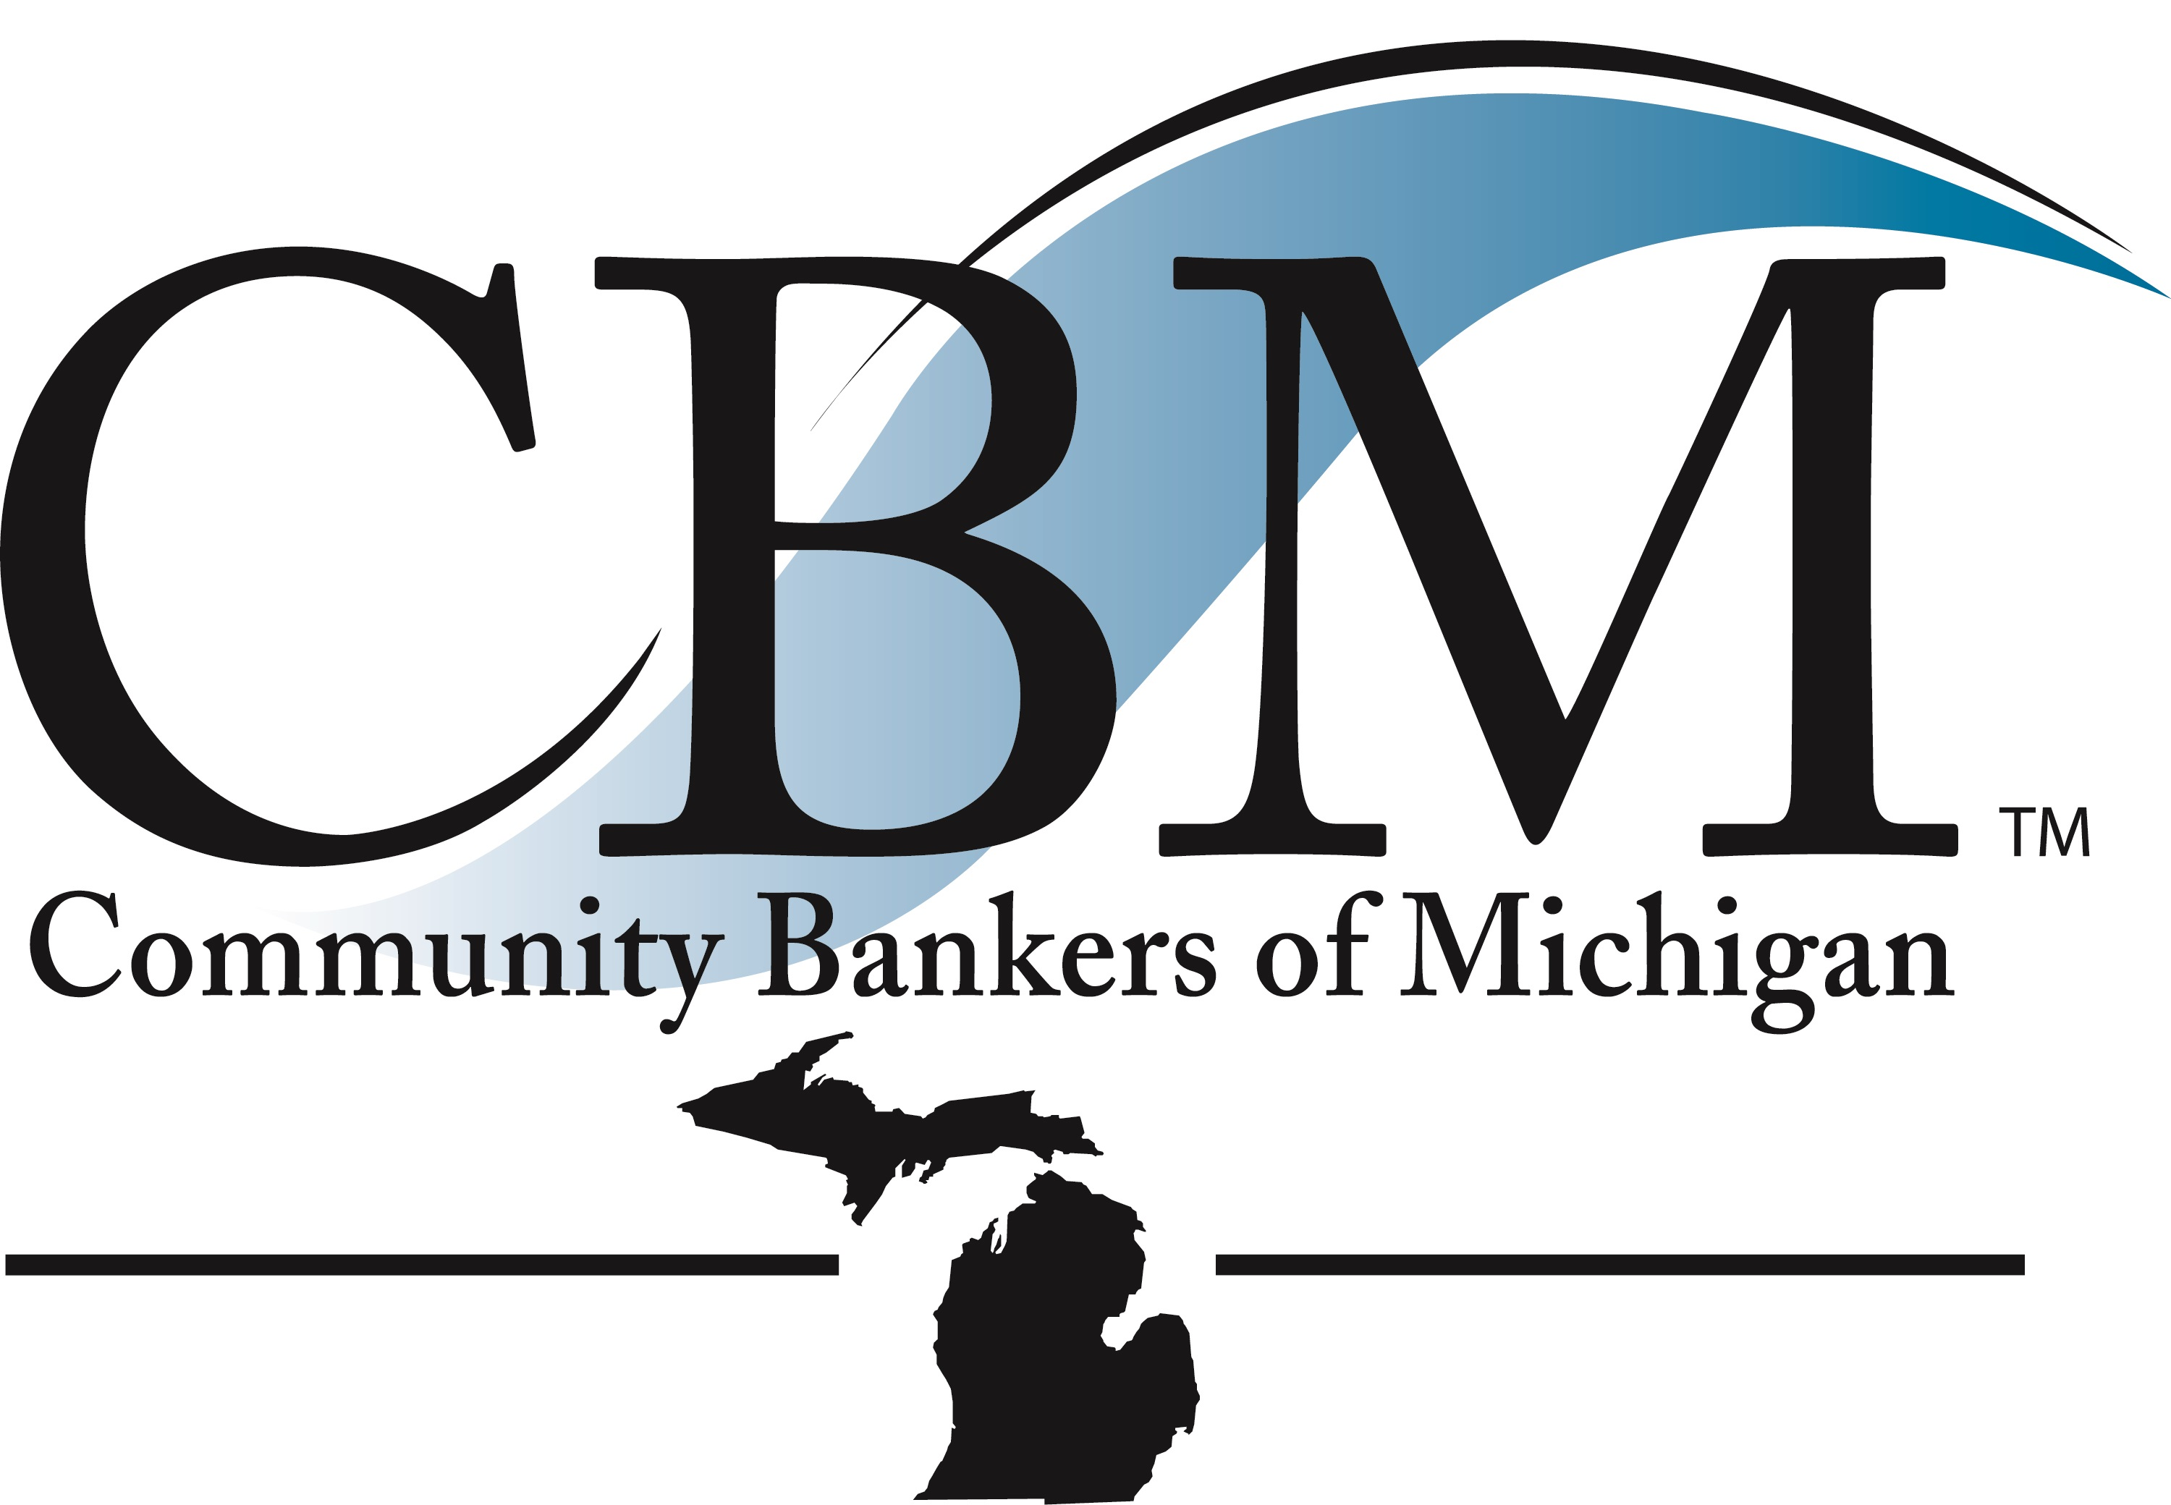

Community Bankers of Michigan (CBM) is proud to present you advertising and editorial opportunities within its official magazine and on our website:

Banking is a dynamic industry. CBM’s Community Spirit never stops evolving in order to exclusively provide Michigan’s community banking industry with up-to-date information on current issues, challenges and news about peers and colleagues.

With six (6) publications produced each year, the Community Spirit reaches every CBM bank and associate within its membership. By advertising in the magazine, on our website, or submitting editorial content, your company shows interest in serving Michigan community banks and confirms your support of the one statewide association that exclusively represents them.

- 2021 Community Spirit Advertisement Size and Per Issue Pricing:

CBM Member Non-Member
Full Page (6 ½” x 10”) $800 $1,160
Inside or Outside Back Cover (6 ½”x10”) $850 $1,250
Front Inside Cover (6 ½”x 10”) $850 $1,250
Half Page $550 $ 845
(6 ½” x 4 ½” horizontal or
4 ¼” x 6 ½” vertical)
One-Quarter Page $425 $ 640
(4 ½” x 3 ½” horizontal or
3 ½” x 4 ½” vertical)

- 2021 Website Advertising: $250 for each month advertising on website

Specifications for securing advertising (for magazine or website) and editorial space:

- All ads must be submitted electronically via e-mail to info@cbofm.org.
- Resolution: 300 dpi for .jpgs or .tifs and 600 dpi for .bmps.
- The ad, or change of copy, must be received by the due date listed on the contract. (For multiple publication participants: If change of copy does not arrive by the submission due date, the previous ad submitted will be run.)
- A signed advertising space contract must be completed (see reverse side) and submitted to CBM in advance of the publication requested. Editorial content will be reviewed and published at CBM’s discretion.
- Advertising cancellations will not be accepted after space closing deadlines.
- Payment for the advertisement will be due 30 days from publication.
- CBM reserves the right for approval of all advertising and editorial copy and to re-schedule the publication of these items, if necessary.

COMMUNITY SPIRIT/WEBSITE – 2021 Advertising/Editorial Contract

Ad, Editorial, and Website Submission Deadline Dates:

√ | Issue | Submission Date |  | √ | Issue | Submission Date
 | #1 February | January 21, 2021 |  |  | #2 April | March 25, 2021
 | #3 June | May 20, 2021 |  |  | #4 August* | July 22, 2021
 | #5 October** | September 30, 2021 |  |  | #6 December | November 18, 2021

* Publication is pre-CBM Annual Convention September 15-17, 2021
**Publication is post CBM September Annual Convention

Company: ________________________________________________________

Advertising Contact: ________________________________________________

Phone and E-Mail Address: ___________________________________________

Mailing Address for Billing: __________________________________________

We will participate in the selected issues above at the ad size of:

_____ Full Page – 4 Color (6 ½” x 10”)
_____ Inside Front, Inside or Outside Back Cover (6 ½” x 10”)
_____ Half Page – _____ (6 ½” x 4 ½”) horizontal OR _____ (4 ¼” x 6 ½”) vertical
_____ One-Quarter Page – _____ (4 ½” x 3 ½”) horizontal OR _____ (3 ½” x 4 ½”) vertical

_____Website advertising
Month(s) requested ________________________________________________

Special Information: _____________________________________________________________

Signature:______________________________________________Date:___________________

Please fax to 517-336-7833 or e-mail info@cbofm.org
Community Bankers of Michigan
830 W. Lake Lansing Road, Ste. 250
East Lansing, MI 48823

