Save time and money with CBM Preferred Partners
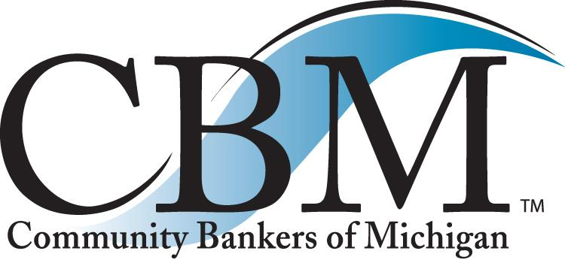

Exceptional products and significant discounts!

When researching new service providers, or rethinking current ones, consider the CBM Preferred Vendor Companies. Those listed below earned the CBM seal of approval, including special pricing for our members. We have completed extensive due diligence with each company available for your review. Explore the revenue-enhancement opportunities with these vendors and improve your bottom line! Give us a call at 517-336-4430 or visit CBM online at www.cbofm.org to obtain more information on the companies listed below.
CAPTRUST Financial Advisors – 401K Provider - Specializing in a holistic approach to retirement plan consulting encompassing all areas of plan oversight.
Casey Pogodzinski – caseypogodzinski@captrustadvisors.com 248-620-8100

Community Bankers Insurance Agency – Employee Benefits – Supported by Michigan Planners and A.E. Mourad, this is a comprehensive benefits program including an internet portal.
Kate Angles –kateangles@cbofm.org– 517-336-4430

Computer Services, Inc (CSI) – Board Communications – Secure Document Delivery – Intranet solution combining a series of powerful communication tools and productivity applications in a single portal.
Bill Evers – bill.evers@csiweb.com – 219-929-8337

EBS, a bank consulting company– Executive Benefits - BOLI – Marketing, consulting and service firm specializing in the administration and placement of BOLI programs.
Kirk Anderson – kanderson@ebscomp.com – 248-244-6076

FF&S – Office Supplies and Printing – Creating savings by optimizing the planning, purchasing and inventory management of operating business materials.
Trent Dalhstrom – tdahlstrom@ffssolutions.com - 517-209-7023

FiNet – Merchant Services – Credit Card Processing – Providing a network of merchant payment processing services.
Richard Camardo – rcamardo@finetsolutions.com – 800-487-5577

Financial Furnishings, Inc. – Office Furniture Discounts – Premier discount resource for superior quality desks, workstation systems, seating, filing solutions, conference and training environments.
John Fountain – johnf@financialfurishings.com – 800-769-8841

HUB International – Insurance programs – Specializing in designing program coverage areas and remediating existing policies.
Debra McManigle – debra.mcmanigle@hubinternational.com
- 269-441-5058

ICBA Securities – Bank Investments – Bonds – Provides a full suite of investment products and services.
Jim Reber – jreber@icbasecurities.com – 800-422-6442
ICBA Bancard & TCM Bank – Credit Card Program – Competitive credit, debit, and merchant processing options to help strengthen consumer and small business relationships.
Julie Hanson – julie.hanson@icba.org – 608-873-9374

International Marketing & Administration Company (IMAC) – Direct Marketing – Income Opportunities – Offers direct marketed consumer appreciation programs.
Kate Angles – kateangles@cbofm.org – 517-336-4430

Investment Professionals, Inc. (IPI) – Retail Investments – Multi-product insurance platform directly through your bank website.
Jay Lavender – j.lavender@invpro.com – 210-288-1981

Investors Title Company – Multi-bank owned title insurance program and Home Equity Title Insurance – Full instant coverage title insurance.
Sky Weaver - skyweaver@invtitle.com – 989-387-8869

JLH Associates, LLC – Compliance – Insurance Review – Risk Management – Industry expert in the area of non-deposit programs, insurance and financial service programs.
Jim Harvin – jharvin@jlhassociatesllc.com – 517-351-4158

Message On Hold – Custom Message On Hold Programs – Offering product and service messaging to ensure customers are kept current with bank offerings.
Kate Angles – kateangles@cbofm.org – 517-336-4430

Miedema Asset Management Group – Repossession Liquidation Services – Offering a one-stop-shop for all remarketing and repossession needs.
Jared Hekstra – jared@1800lastbid.com – 616-291-7003

Ncontracts – 3rd Party Vendor and Contract Management – Providing web-based vendor and contract management services for financial institutions.
Jessie Hogue – jessie.hogue@ncontracts.com – 317-513-0729

NetGain Technologies – IT resource – Outsource IT services – Experts in architectural design, implementation and management of high performance IT solutions.
Nigel Taylor – ntaylor@netgainit.com – 859.226.1964

PM Environmental, Inc. – Environmental risk expert - Consulting and management of environmental, engineering, industrial hygiene, energy and development projects
Mike Kulka – kulka@pmenv.com – 248-414-1425

Seattle Specialty Insurance Services, Inc. (SSIS) – Force Placed Insurance - Income Opportunity – Largest provider of collateral insurance coverage and specialized services to the community banking industry.
Kate Angles – kateangles@cbofm.org – 517-336-4430

SBA Complete, Inc. – Outsourced SBA loan solutions – Conducts portfolio reviews, offers solution for reporting and loan servicing in addition to complete SBA lending solutions.
Richard Carlson – rcarlson@sbacomplete.com – 619-847-6468

SHAZAM – A national single source provider of the following services: debit card, core, fraud, ATM,
To learn more visit shazam.net.
Andrew Huth - ahuth@shazam.net – 800-278-8150

Travelers – Bank Insurance – Offering a wide range of commercial insurance coverages for financial institutions.
Andrew Hatheway – amhathew@travelers.com – 317-818-0195

UPS – Shipping – Overnight Shipping – Range of options for the synchronized movement of goods, information and funds.
Barb Mackie – bmackie@ups.com – 517-204-9122

Watermark Employee Benefits, LLC– Commercial Borrower Disability Insurance – Protection for banks by insuring commercial loans with the best coverage available at fraction of the cost.
Zac Woodward – zac@watermarkeb.com – 616-248-0100

