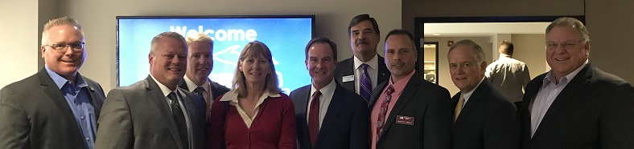

Pictured (L to R): Cortney Collison, Union Bank; Jim North, First National Bank of St. Ignace; Bryan Wallace, CBM; Kate Angles, CBM; Bill Schuette, Michigan Attorney General; Bob Wolak, Chemical Bank; Kevin Collison, Commercial Bank; Michael Tierney, CBM; Gary Sharp, Old Mission Bank

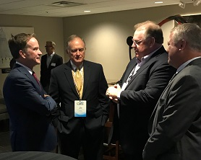

Pictured (L to R): Bill Schuette, Michigan Attorney General; Michael Tierney, CBM; Gary Sharp, Old Mission Bank; Jim North, First National Bank of St. Ignace

