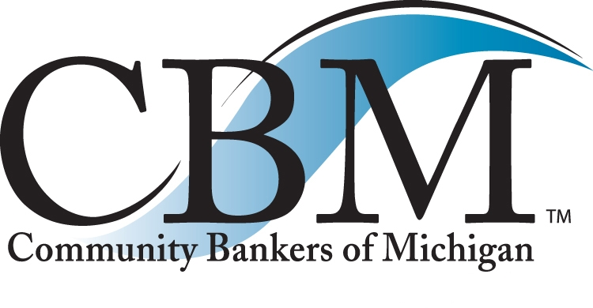

For immediate release Contact: Michael Tierney
Photo available: info@cbofm.org President & CEO
Phone: 517.336.4430
michaeltierney@cbofm.org

Bruce Cady and Jay Dubey Receive 2018 “Best of Community Banking” Award at Community Bankers of Michigan Annual Convention

TRAVERSE CITY — Robert Wolak, Chairman of Community Bankers of Michigan (CBM), today announced that Bruce Cady and Jay Dubey received the “Best of Community Banking” Award for 2018 at the Community Bankers of Michigan Annual Convention, held this week at the Grand Traverse Resort in Traverse City. Community Bankers of Michigan is a 250-member trade association serving community banks, and their financial services partners, throughout Michigan.

Cady is Chairman and CEO of Lakestone Bank & Trust in Lapeer and Dubey is President and CEO of Thumb Bank & Trust in Pigeon.

“As the incoming Chair for Community Bankers of Michigan, I am extremely honored to present the awards to Bruce Cady and Jay Dubey,” said Wolak, President and CEO of Chemical Bank in Caro, and who will also serve as CBM Chairman for the next year. “Bruce and Jay are outstanding community bank leaders. They run great banks and they are civic minded leaders involved in nearly every aspect of their communities.”

“I am very flattered and thankful for the recognition by the banking industry in Michigan. It is especially humbling to be recognized by my peers,” Cady said. “It is an honor to join the group of distinguished bankers who have been prior award winners and who have done so much for their communities throughout the state of Michigan.”

Bruce Cady began his banking career in 1975 with National Bank of Detroit after graduating from the University of Arizona with a degree in Business Administration.
“Bruce worked his way up to ever increasing roles of responsibilities with stops at First of America and National City before he moved to Lapeer County Bank & Trust Co. in 1999,” Wolak adds. “Bruce became President in 2005 and added the title of CEO in 2006. He served in that capacity through 2016, when following the merger of Lapeer County Bank & Trust Co. and CSB Bank he was named Chairman and CEO of the Board of the combined banks.” Bruce was a long serving board member of the CBM.

Wolak credited Cady with being instrumental in leading the recent merger efforts and ushering in the new name of the combined banks of Lakestone Bank & Trust. “Under Bruce's guidance the bank has grown from $265M in assets to over $600M. Total loans have grown from $186M to $344M.”

Wolak noted that Cady and his family moved to Lapeer in 1988. “From the start Bruce has exhibited the true spirit of community banking. He was a key member of the committee that brought Emergency 911 Dispatch to Lapeer County. He also led the effort to bring a fireworks display back to Lapeer to celebrate the 4th of July, which is still in place today,” Wolak said.

“All of us working with the Community Bankers of Michigan are passionate advocates for community banking,” said Mike Tierney, President and CEO of Community Bankers of Michigan. “Bruce is one of the leading voices for Community Banking in Michigan. He has been a strong industry advocate in Lansing as well as Washington DC. Bruce is one of the most respected bankers in Michigan and was a long serving board member of the CBM.”

Wolak praised Jay Dubey’s commitment as a member of the Board of Directors of the Community Bankers of Michigan for many years, serving as Chairman in 2010. “His passion has been to serve CBM members as an advocate for fair banking laws in Congress and the State legislature, and he has traveled to Washington DC and Lansing many times to advocate for Community Bankers.” Mike Tierney the President and CEO of the CBM commented “Jay has been a great board member for us. He always answers the call when our industry needs a champion. He knows his way around Lansing and Washington D.C. and he is a highly respected leader in Michigan banking circles. Jay served on the ICBA (Independent Community Bankers of America) agricultural loan committee for many years lending his expertise in agricultural lending to benefit community banks across America and to bring innovative financing options to Michigan farm families.”

“I am very honored by the recognition bestowed upon me by my fellow bankers. It is especially humbling to be recognized by bankers I admire, and by the CBM - the voice of community banking in Michigan.” Dubey said.

Wolak said that in the spirit of community banking Jay has been very active in the Pigeon community. As a devoted member of the Pigeon Rotary Club for 39 years, he received the "Governor's Service Award" for tireless service to Rotary, Community, and the World. He is also a Paul Harris Fellow. His community service includes, past President and a career long member of the Pigeon Chamber of Commerce, Little league baseball coach, and countless local school committees. He has served on the Board of Directors of Scheurer Hospital for over 30 years, serving as Chairman In 2009

“Jay is a 1972 graduate of Elkton-Pigeon-Bay Port High School, and earned his BS Degree from Michigan State University in 1976,” Wolak adds. “He began his banking career at Thumb National Bank in 1978, and is a graduate of the Perry School of Banking, and the Graduate School of Banking at the University of Wisconsin.”

Mike Tierney, President and CEO of Community Bankers of Michigan, said “Bruce and Jay are leading advocates for community banking in Michigan. They have been strong industry voices in Lansing as well as Washington DC., and are two of the most respected community bankers in Michigan.”

About “Best of Community Banking” Award
The “Best of Community Banking” Award is given each year at the Community Bankers of Michigan Annual Convention. The award recognizes the contributions and success of a Michigan community banker. Special recognition is given to community bankers who have made significant contributions to their communities and the community banking industry.

About Community Bankers of Michigan (CBM)
The Community Bankers of Michigan is a 250-member trade association serving community banks, and their financial services partners, throughout Michigan. With headquarters in East Lansing, Mich., the Community Bankers of Michigan is dedicated exclusively to representing the interests of the community banking industry and its membership through effective advocacy, professional education programs and high-quality products and services. For more information, visit http://www.cbofm.org.
One Mission. Community Banks.

###

